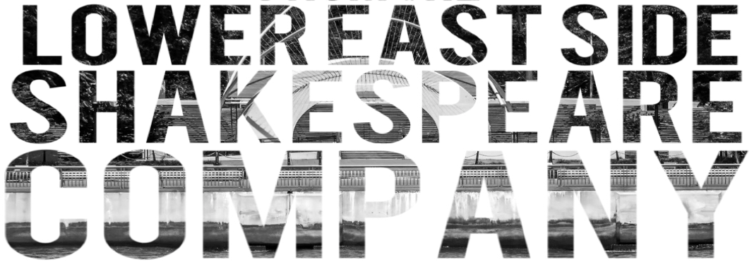
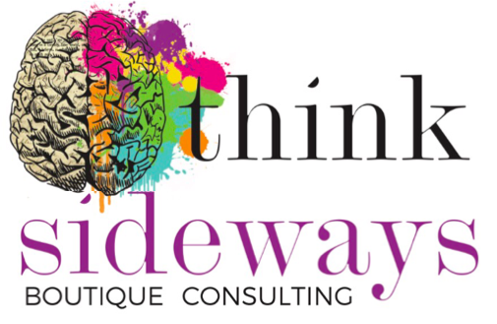

Registration & Payment Form

for

The Illusion of Stress & Boredom

and/or

Taking Your Rightful Place On Stage

August/September 2016 Workshops Application Dates:
Applications Open: Aug 3rd, 2016
Application Deadline: Aug 10th, 2016

How to Register

Thank you for expressing your interest. To complete your registration, answer the following questions in the fields below & submit this form via the instructions for whichever payment method best suits your needs. All submissions must be made before August 10th for acceptance. Finally, please be sure to complete the consent section.

Name of Parent/Guardian:

Email of Parent/Guardian:

Phone Number of Parent/Guardian (if case of emergency):

Student Name:

Student Age:

Which workshop are you applying for?

The Illusion of Stress & Boredom ($160.00)

Taking Your Rightful Place On Stage ($160.00)

Both ($320.00)

Payment Methods:

Direct Deposit:

Name Chantelle Goulevitch

BSB 084-828

ACC 53-289-0198

*Note: If you pay via direct deposit, please email this form to chantelle@think-sideways.com.au with the name of the account that the funds will be transferred from. You will be emailed a receipt upon acceptance of funds.

Name of payment account:

Credit Card or Cash:

High Country Enterprises Mitre 10 has kindly agreed to accept cash & credit card payments for the workshops. If you wish to pay via one of these methods you will need to give them a completed copy of this form upon payment. They will be able to issue you a receipt at the store if needed.

Parental Consent:

I give permission for to attend and participate in the workshop/s mentioned above.

